Information systems Assignment

*(6G4Z1103)*

**Part 3- DB Design & ORACLE Implementation**

**Alexander Harrison (17080341)**

**Lewis Frater (17081955)**

**Callum Flanagan (17028406)**

**Rebecca Clarke(17032866)**

**Antreas Christofi(17083606)**

2017-2018

**TABLE OF CONTENTS**

**Page -**

**Page -**

This report will highlight what we have done in part 3, db design and oracle implementation of the Ray Rentals Assignment. This report will include our amended ERD which we changed based on the feedback we received, our data dictionaries, screenshots of the SQL code for the database tables, insert statements as well as queries. Finally our report will show a paragraph of commentary from each student explaining what we have learnt, evaluating our contribution as well as what we could have done better.

Amended ERD

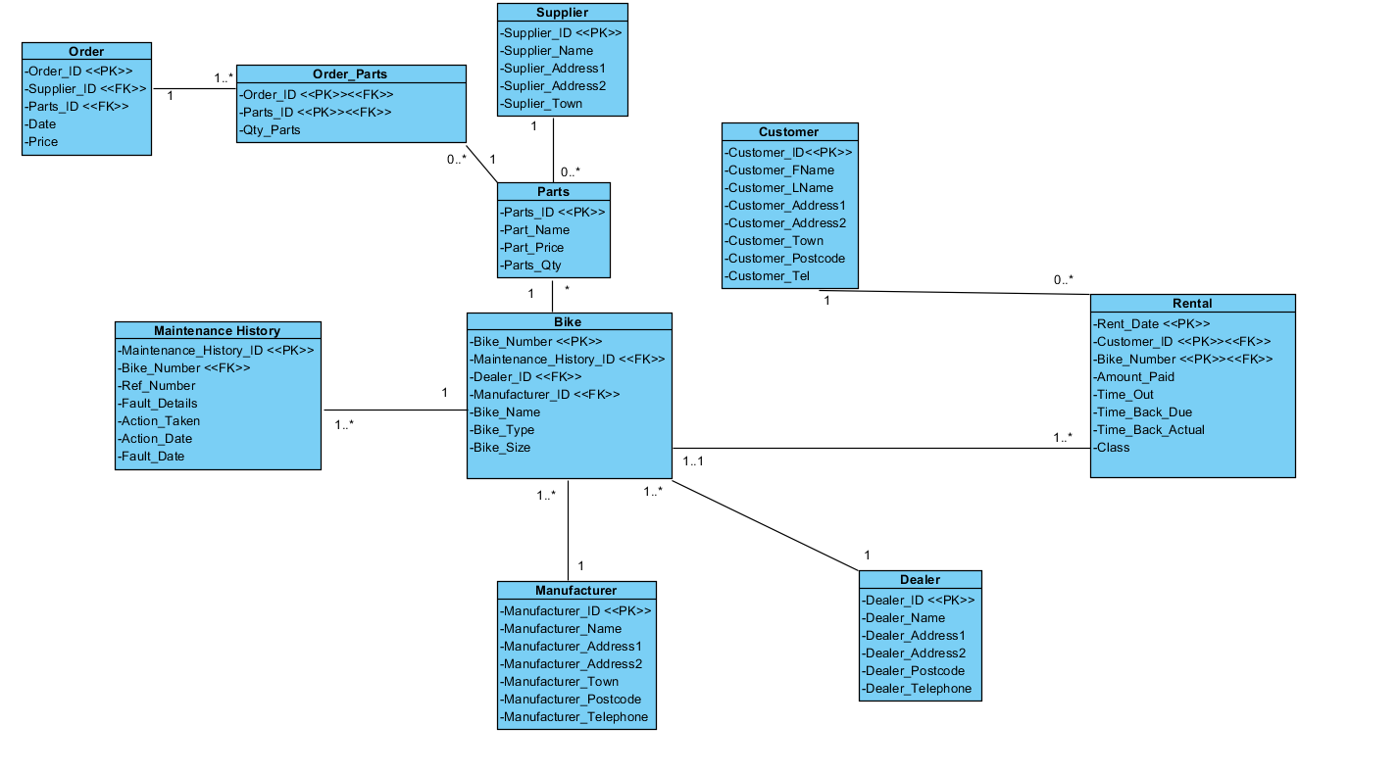

Data Dictionaries

**Table : Customer**

|  |  |  |  |  |  |  |
| --- | --- | --- | --- | --- | --- | --- |
| **Attribute Name** | **Key Type** | **FK Table** | **FK Column** | **Data Type** | **Length** | **Constraint** |
| CUST_ID | PK |  |  | NUMBER | 9 | UNIQUE, NOT NULL,PRIMARY KEY |
| CUST_LNAME |  |  |  | VARCHAR2 | 30 | NOT NULL |
| CUST_FNAME |  |  |  | VARCHAR2 | 30 | NOT NULL |
| CUST_ADDRESS1 |  |  |  | VARCHAR2 | 30 | NOT NULL |
| CUST_ADDRESS2 |  |  |  | VARCHAR2 | 30 | NOT NULL |
| CUST_TOWN |  |  |  | VARCHAR2 | 30 | NOT NULL |
| CUST_POSTCODE |  |  |  | VARCHAR2 | 8 | NOT NULL |
| CUST_TELEPHONE |  |  |  | VARCHAR2 | 15 | NOT NULL |

By Lewis Frater

**Table : Rental**

|  |  |  |  |  |  |  |
| --- | --- | --- | --- | --- | --- | --- |
| **Attribute Name** | **Key Type** | **FK Table** | **FK Column** | **Data Type** | **Length** | **Constraint** |
| RENT_DATE | PK |  |  | DATE | DD/MM/YY | NOT NULL,PRIMARY KEY |
| CUST_ID | PK | FK | CUSTOMER | NUMBER | 9 | UNIQUE, NOT NULL,FOREIGN KEY |
| BIKE_NUMBER | PK | FK | BIKE | NUMBER | 9 | UNIQUE, NOT NULL,FOREIGN KEY |
| AMOUNT_PAID |  |  |  | NUMBER | 30 | NOT NULL |
| TIME_OUT |  |  |  | TIME | hh:mm[:ss] | NOT NULL |
| TIME_DUEBACK |  |  |  | TIME | hh:mm[:ss] | NOT NULL |
| TIME_BACBACK |  |  |  | TIME | hh:mm[:ss] | NOT NULL |

By Lewis Frater

**Table : Bike**

|  |  |  |  |  |  |  |
| --- | --- | --- | --- | --- | --- | --- |
| **Attribute Name** | **Key Type** | **FK Table** | **FK Column** | **Data Type** | **Length** | **Constraint** |
| BIKE_NUMBER | PK |  |  | NUMBER | 9 | UNIQUE,NOT NULL,PRIMARY KEY |
| MAINTENANCE_HIS | FK | FK | MAINTENANCE_HISTORY | VARCHAR2 | 30 | CHECK,FOREIGN KEY |
| DEALER_ID | FK | FK | DEALER | VARCHAR2 | 30 | NOT NULL,FOREIGN KEY |
| MANUFACTURER_ID | FK | FK | MANUFACTURER | VARCHAR2 | 30 | NOT NULL,FOREIGN KEY |
| BIKE_NAME |  |  |  | VARCHAR2 | 15 | NOT NULL |
| BIKE_TYPE |  |  |  | VARCHAR2 | 15 | NOT NULL |
| BIKE_SIZE |  |  |  | VARCHAR2 | 30 | NOT NULL |

By Rebecca Clarke

**Table : DEALER**

|  |  |  |  |  |  |  |
| --- | --- | --- | --- | --- | --- | --- |
| **Attribute Name** | **Key Type** | **FK Table** | **FK Column** | **Data Type** | **Length** | **Constraint** |
| DEALER_ID | PK |  |  | NUMBER | 9 | UNIQUE,NOT NULL,PRIMARY KEY |
| DEALER_NAME |  |  |  | VARCHAR2 | 30 | NOT NULL |
| DEALER_ADDRESS1 |  |  |  | VARCHAR2 | 30 | NOT NULL |
| DEALER_ADDRESS2 |  |  |  | VARCHAR2 | 30 | NOT NULL |
| DEALER_POSTCODE |  |  |  | VARCHAR2 | 10 | NOT NULL |
| DEALER_PHONE |  |  |  | VARCHAR2 | 15 | NOT NULL |

By Alexander Harrision

**Table : MANUFACTURER**

|  |  |  |  |  |  |  |
| --- | --- | --- | --- | --- | --- | --- |
| **Attribute Name** | **Key Type** | **FK Table** | **FK Column** | **Data Type** | **Length** | **Constraint** |
| MANUFACTURER_ID | PK |  |  | NUMBER | 9 | UNIQUE, NOT NULL, PRIMARY KEY |
| MANUFACTURER_NAME |  |  |  | VARCHAR2 |  | NOT NULL |
| MANUFACTURER_ADDRESS1 |  |  |  | VARCHAR2 | 30 | NOT NULL |
| MANUFACTURER_ADDRESS2 |  |  |  | VARCHAR2 | 30 | NOT NULL |
| MANUFACTURER_TOWN |  |  |  | VARCHAR2 | 30 | NOT NULL |
| MANUFACTURER_POSTCODE |  |  |  | VARCHAR2 | 10 | NOT NULL |
| MANUFACTURER_PHONE |  |  |  | VARCHAR2 | 15 | NOT NULL |

By Callum Flanagan

**Table : Maintenance History**

|  |  |  |  |  |  |  |
| --- | --- | --- | --- | --- | --- | --- |
| **Attribute Name** | **Key Type** | **FK Table** | **FK Column** | **Data Type** | **Length** | **Constraint** |
| MAINTENANCE_HISTORY_ID | PK |  |  | NUMBER | 9 | UNIQUE,NOT NULL,PRIMARY KEY |
| BIKE_NUMBER | FK | FK | BIKE | VARCHAR2 | 30 | NOT NULL,FOREIGN KEY |
| REF_NUMBER |  |  |  | VARCHAR2 | 30 | UNIQUE,NOT NULL |
| FAULT_DETAILS |  |  |  | VARCHAR2 | 400 | CHECK |
| ACTION_TAKEN |  |  |  | VARCHAR2 | 400 | CHECK |
| ACTION_DATE |  |  |  | DATE | DD/MM/YY | CHECK |
| FAULT_DATE |  |  |  | DATE | DD/MM/YY | CHECK |

By Callum Flanagan

**Table : PARTS**

|  |  |  |  |  |  |  |
| --- | --- | --- | --- | --- | --- | --- |
| **Attribute Name** | **Key Type** | **FK Table** | **FK Column** | **Data Type** | **Length** | **Constraint** |
| PARTS_ID | PK |  |  | NUMBER | 9 | UNIQUE, NOT NULL,PRIMARY KEY |
| PARTS_NAME |  |  |  | VARCHAR2 | 30 | NOT NULL |
| PARTS_PRICE |  |  |  | NUMBER | 10 | NOT NULL |
| PARTS_QTY |  |  |  | NUMBER | 4 | NOT NULL |

By Alexander Harrision

**Table : ORDER PARTS**

|  |  |  |  |  |  |  |
| --- | --- | --- | --- | --- | --- | --- |
| **Attribute Name** | **Key Type** | **FK Table** | **FK Column** | **Data Type** | **Length** | **Constraint** |
| ORDER_ID | PK | FK | ORDER | NUMBER | 9 | UNIQUE, NOT NULL,PRIMARY KEY |
| PARTS_ID | PK | FK | PARTS | NUMBER | 9 | UNIQUE, NOT NULL,PRIMARY KEY |
| QTY_PARTS |  |  |  | NUMBER | 4 | NOT NULL |

By Rebecca Clarke

**Table : SUPPLIER**

|  |  |  |  |  |  |  |
| --- | --- | --- | --- | --- | --- | --- |
| **Attribute Name** | **Key Type** | **FK Table** | **FK Column** | **Data Type** | **Length** | **Constraint** |
| SUPPLIER_ID | PK |  |  | NUMBER | 9 | UNIQUE, NOT NULL,PRIMARY KEY |
| SUPPLIER_NAME |  |  |  | VARCHAR2 | 30 | NOT NULL |
| SUPPLIER_ADDRESS1 |  |  |  | VARCHAR2 | 30 | NOT NULL |
| SUPPLIER_ADDRESS2 |  |  |  | VARCHAR2 | 15 | NOT NULL |
| SUPPLIER_TOWN |  |  |  | VARCHAR2 | 15 | NOT NULL |

By Andreas Christofi

**Table : ORDER**

|  |  |  |  |  |  |  |
| --- | --- | --- | --- | --- | --- | --- |
| **Attribute Name** | **Key Type** | **FK Table** | **FK Column** | **Data Type** | **Length** | **Constraint** |
| ORDER_ID | PK |  |  | NUMBER | 9 | UNIQUE, NOT NULL,PRIMARY KEY |
| SUPPLIER_ID | FK | FK | SUPPLIER | NUMBER | 9 | UNIQUE, NOT NULL,FOREIGN KEY |
| PARTS_ID | FK | FK | PARTS | NUMBER | 9 | UNIQUE, NOT NULL,FOREIGN KEY |
| DATE |  |  |  | DATE | DD/MM/YY | NOT NULL |
| PRICE |  |  |  | NUMBER | 15 | NOT NULL |

By Andreas Christofi

SQL Database Tables (With Insert Statements)

DROP TABLE ORDER_PARTS;

DROP TABLE RR_ORDER;

DROP TABLE PARTS;

DROP TABLE SUPPLIER;

DROP TABLE RENTAL;

DROP TABLE BIKE;

DROP TABLE MANUFACTURER;

DROP TABLE MAINTENANCE_HISTORY;

DROP TABLE DEALER;

DROP TABLE RR_CUSTOMER;

CREATE TABLE RR_CUSTOMER

(

RR_CUSTOMER_ID NUMBER(9) PRIMARY KEY NOT NULL,

CUST_LNAME VARCHAR2(30) NOT NULL,

CUST_FNAME VARCHAR2(30) NOT NULL,

CUST_ADDRESS1 VARCHAR2(30) NOT NULL,

CUST_ADDRESS2 VARCHAR2(30) ,

CUST_TOWN VARCHAR2(30) NOT NULL,

CUST_POSTCODE VARCHAR2(8) NOT NULL,

CUST_TELEPHONE VARCHAR2(15) NOT NULL

--By Lewis Frater

);

CREATE TABLE DEALER

(

DEALER_ID NUMBER(9) PRIMARY KEY NOT NULL,

DEALER_NAME VARCHAR2(30) NOT NULL,

DEALER_ADDRESS1 VARCHAR2(30) NOT NULL,

DEALER_ADDRESS2 VARCHAR2(30) NOT NULL,

DEALER_TOWN VARCHAR2(30) NOT NULL,

DEALER_POSTCODE VARCHAR2(10) NOT NULL,

DEALER_PHONE VARCHAR2(15) NOT NULL

--By Alexander Harrison

);

CREATE TABLE MAINTENANCE_HISTORY

(

MAINTENANCE_HISTORY_ID NUMBER(9) PRIMARY KEY NOT NULL,

BIKE_NUMBER VARCHAR2(30) NOT NULL,

FAULT_DETAILS VARCHAR2(400) NOT NULL,

ACTION_TAKEN VARCHAR2(400) NOT NULL,

ACTION_DATE DATE NOT NULL,

FAULT_DATE DATE NOT NULL

);

--BY CALLUM FLANAGAN

CREATE TABLE MANUFACTURER(

MANUFACTURER_ID NUMBER(9) PRIMARY KEY NOT NULL,

MANUFACTURER_NAME VARCHAR2(30) NOT NULL,

MANUFACTURER_ADDRESS1 VARCHAR2(30) NOT NULL,

MANUFACTURER_ADDRESS2 VARCHAR2(30) NOT NULL,

MANUFACTURER_TOWN VARCHAR2(30) NOT NULL,

MANUFACTURER_POSTCODE VARCHAR2(8) NOT NULL,

MANUFACTURER_PHONE VARCHAR2(15) NOT NULL

);

--BY CALLUM FLANAGAN

CREATE TABLE BIKE

(

BIKE_NUMBER NUMBER(9) PRIMARY KEY NOT NULL,

MAINTENANCE_HISTORY_ID NUMBER(9) NOT NULL,

DEALER_ID NUMBER(9) NOT NULL,

MANUFACTURER_ID NUMBER(9) NOT NULL,

BIKE_NAME VARCHAR2(15) NOT NULL,

BIKE_TYPE VARCHAR2(15) NOT NULL,

BIKE_SIZE VARCHAR2(30) NOT NULL,

CONSTRAINT FK_MAINTENANCE_HISTORY FOREIGN KEY (MAINTENANCE_HISTORY_ID)

REFERENCES MAINTENANCE_HISTORY(MAINTENANCE_HISTORY_ID),

CONSTRAINT FK_DEALER_ID FOREIGN KEY (DEALER_ID)

REFERENCES DEALER(DEALER_ID),

CONSTRAINT FK_MANUFACTURER_ID FOREIGN KEY (MANUFACTURER_ID)

REFERENCES MANUFACTURER (MANUFACTURER_ID)

); --BY REBECCA CLARKE

CREATE TABLE RENTAL

(

RENT_DATE DATE PRIMARY KEY NOT NULL,

RR_CUSTOMER_ID NUMBER(9) NOT NULL,

BIKE_NUMBER NUMBER(9) NOT NULL,

AMOUNT_PAID NUMBER(30) NOT NULL,

TIME_OUT NUMBER(9) ,

TIME_DUEBACK NUMBER(9) ,

TIME_ACBACK NUMBER(9) ,

CONSTRAINT FK_CUST_ID FOREIGN KEY (RR_CUSTOMER_ID)

REFERENCES RR_CUSTOMER(RR_CUSTOMER_ID),

CONSTRAINT FK_BIKE_NUMBER FOREIGN KEY (BIKE_NUMBER)

REFERENCES BIKE (BIKE_NUMBER)

--By Lewis Frater

);

CREATE TABLE SUPPLIER

(

SUPPLIER_ID NUMBER(9) PRIMARY KEY NOT NULL,

SUPPLIER_NAME VARCHAR2(30) NOT NULL,

SUPPLIER_ADDRESS1 VARCHAR2(30) NOT NULL,

SUPPLIER_ADDRESS2 VARCHAR2(15) NOT NULL,

SUPPLIER_TOWN VARCHAR2(15) NOT NULL

);

--BY ANDREAS CHRISTOFI

CREATE TABLE PARTS

(

PARTS_ID NUMBER(9) PRIMARY KEY NOT NULL,

PARTS_NAME VARCHAR2(30) NOT NULL,

PARTS_PRICE NUMBER(10) NOT NULL,

PARTS_QTY NUMBER(4) NOT NULL

--By Alexander Harrison

);

CREATE TABLE RR_ORDER

(

ORDER_ID NUMBER(9) PRIMARY KEY NOT NULL,

SUPPLIER_ID NUMBER(9) NOT NULL,

PARTS_ID NUMBER(9) NOT NULL,

ORDER_DATE DATE NOT NULL,

PRICE NUMBER(15) NOT NULL,

CONSTRAINT FK_PARTS_ID FOREIGN KEY (PARTS_ID)

REFERENCES PARTS(PARTS_ID),

CONSTRAINT FK_SUPPLIER_ID FOREIGN KEY (SUPPLIER_ID)

REFERENCES SUPPLIER (SUPPLIER_ID)

);

--BY ANDREAS CHRISTOFI

CREATE TABLE ORDER_PARTS

(

ORDER_ID NUMBER(9) NOT NULL,

PARTS_ID NUMBER(9) NOT NULL,

QTY_PARTS NUMBER(4) NOT NULL,

PRIMARY KEY(ORDER_ID, PARTS_ID)

);

--LEWIS FRATER

INSERT INTO RR_CUSTOMER (RR_CUSTOMER_ID, CUST_LNAME, CUST_FNAME, CUST_ADDRESS1,

CUST_ADDRESS2, CUST_TOWN, CUST_POSTCODE, CUST_TELEPHONE)

VALUES (1, 'Stjohn', 'Donna', '248 Pleasant Hill Road', 'Salford', 'Manchester', 'M13 7FS', 01612053232);

INSERT INTO RR_CUSTOMER (RR_CUSTOMER_ID, CUST_LNAME, CUST_FNAME, CUST_ADDRESS1,

CUST_ADDRESS2, CUST_TOWN, CUST_POSTCODE, CUST_TELEPHONE)

VALUES (2, 'Gerry', 'Twock', '21 Danger Close', 'Euston', 'London', 'AB1 0AR', 02072043088);

INSERT INTO RR_CUSTOMER (RR_CUSTOMER_ID, CUST_LNAME, CUST_FNAME, CUST_ADDRESS1,

CUST_ADDRESS2, CUST_TOWN, CUST_POSTCODE, CUST_TELEPHONE)

VALUES (3, 'Ropes', 'Bailey', '12 Mary lane', 'St Helens', 'Liverpool', 'L18 4HQ', 01516673299);

--ALEXANDER HARRISON

INSERT INTO DEALER(DEALER_ID,DEALER_NAME,DEALER_ADDRESS1,DEALER_ADDRESS2,DEALER_TOWN,DEALER_POSTCODE,DEALER_PHONE)

VALUES(14,'ASH_UK','Unit 7','Holly Gate Center','Stockport','SK6 G24','07423432432432');

INSERT INTO DEALER(DEALER_ID,DEALER_NAME,DEALER_ADDRESS1,DEALER_ADDRESS2,DEALER_TOWN,DEALER_POSTCODE,DEALER_PHONE)

VALUES(62,'GB Bikes','Unit 21', 'Gate Center','glossop','SK13 0BG','074345432432');

INSERT INTO DEALER(DEALER_ID,DEALER_NAME,DEALER_ADDRESS1,DEALER_ADDRESS2,DEALER_TOWN,DEALER_POSTCODE,DEALER_PHONE)

VALUES(92,'Bike ltd','Unit 31','Carfax court','gamesley','SK6 0BG','07454654672');

--CALLUM FLANAGAN

INSERT INTO

Maintenance_History(MAINTENANCE_HISTORY_ID,BIKE_NUMBER,FAULT_DETAILS,ACTION_TAKEN,ACTION_DATE,FAULT_DATE)

VALUES(12,'12','Broken chain','New chain put on the bike','10-MAR-17','12-MAR-17');

INSERT INTO

Maintenance_History(MAINTENANCE_HISTORY_ID,BIKE_NUMBER,FAULT_DETAILS,ACTION_TAKEN,ACTION_DATE,FAULT_DATE)

VALUES(03,'14','Flat tire','New inner tube put on the bike','17-JUN-17','18-JAN-17');

INSERT INTO

Maintenance_History(MAINTENANCE_HISTORY_ID,BIKE_NUMBER,FAULT_DETAILS,ACTION_TAKEN,ACTION_DATE,FAULT_DATE)

VALUES(75,'22','Brakes need bleeding','Brakes have had new brake fluid in them','11-DEC-17','12-AUG-17');

--CALLUM FLANAGAN

INSERT INTO Manufacturer(MANUFACTURER_ID,MANUFACTURER_NAME,MANUFACTURER_ADDRESS1,MANUFACTURER_ADDRESS2,MANUFACTURER_TOWN,MANUFACTURER_POSTCODE,MANUFACTURER_PHONE)

VALUES(1,'Bike Industry', 'Unit 9', 'Dinting Road', 'Glossop', 'SK13 7DY', '07884556767' );

INSERT INTO Manufacturer(MANUFACTURER_ID,MANUFACTURER_NAME,MANUFACTURER_ADDRESS1,MANUFACTURER_ADDRESS2,MANUFACTURER_TOWN,MANUFACTURER_POSTCODE,MANUFACTURER_PHONE)

VALUES(34,'Cycles Limited', ' Long Way', 'Station Road', 'Sheffield', 'JX78 9XW', '07788442323' );

INSERT INTO Manufacturer(MANUFACTURER_ID,MANUFACTURER_NAME,MANUFACTURER_ADDRESS1,MANUFACTURER_ADDRESS2,MANUFACTURER_TOWN,MANUFACTURER_POSTCODE,MANUFACTURER_PHONE)

VALUES(84,'Wheels For You', ' Bridgeway', 'Green Road', 'Birmingham', 'JW45 7KL', '07547896325' );

--BY REBECCA CLARKE

INSERT INTO BIKE(BIKE_NUMBER,MAINTENANCE_HISTORY_ID,DEALER_ID,MANUFACTURER_ID,BIKE_NAME,BIKE_TYPE,BIKE_SIZE)

VALUES(1,12, 14,1, 'SlayerX','Road','LargeMale');

INSERT INTO BIKE(BIKE_NUMBER,MAINTENANCE_HISTORY_ID,DEALER_ID,MANUFACTURER_ID,BIKE_NAME,BIKE_TYPE,BIKE_SIZE)

VALUES(74,03, 62,34,'Thunder','Tamden','Child');

INSERT INTO BIKE(BIKE_NUMBER,MAINTENANCE_HISTORY_ID,DEALER_ID,MANUFACTURER_ID,BIKE_NAME,BIKE_TYPE,BIKE_SIZE)

VALUES(85,75, 92,84, 'LowRiderX','Mountain','StandardMale');

--CALLUM FLANAGAN

INSERT INTO

RENTAL(RENT_DATE ,RR_CUSTOMER_ID, BIKE_NUMBER,AMOUNT_PAID,TIME_OUT,TIME_DUEBACK,TIME_ACBACK)

VALUES('21-DEC-17', 1, 1, 40, 1310, 1625, 1800 );

INSERT INTO

RENTAL(RENT_DATE ,RR_CUSTOMER_ID, BIKE_NUMBER,AMOUNT_PAID,TIME_OUT,TIME_DUEBACK,TIME_ACBACK)

VALUES('12-MAR-17', 2, 74, 4, 1720, 1835, 1900 );

INSERT INTO

RENTAL(RENT_DATE, RR_CUSTOMER_ID, BIKE_NUMBER,AMOUNT_PAID,TIME_OUT,TIME_DUEBACK,TIME_ACBACK)

VALUES('03-AUG-17', 3, 85, 3, 1030, 1345, 1500 );

INSERT INTO ORDER_PARTS(ORDER_ID,PARTS_ID,QTY_PARTS)

VALUES(1,11,12);

INSERT INTO ORDER_PARTS(ORDER_ID,PARTS_ID,QTY_PARTS)

VALUES(82,12,30);

INSERT INTO ORDER_PARTS(ORDER_ID,PARTS_ID,QTY_PARTS)

VALUES(38,55,7);

INSERT INTO PARTS(PARTS_ID,PARTS_NAME,PARTS_PRICE,PARTS_QTY)

VALUES(11,'Bike crank',82,62);

INSERT INTO PARTS(PARTS_ID,PARTS_NAME,PARTS_PRICE,PARTS_QTY)

VALUES(12,'Pedal',5,20);

INSERT INTO PARTS(PARTS_ID,PARTS_NAME,PARTS_PRICE,PARTS_QTY)

VALUES(55,'handlebar',54,2);

--Andreas Christofi

INSERT INTO

SUPPLIER(SUPPLIER_ID,SUPPLIER_NAME, SUPPLIER_ADDRESS1, SUPPLIER_ADDRESS2, SUPPLIER_TOWN )

VALUES(45, 'Willys Wheels', '45 Stretford Rd', 'Hulme', 'Manchester');

INSERT INTO

SUPPLIER(SUPPLIER_ID,SUPPLIER_NAME, SUPPLIER_ADDRESS1, SUPPLIER_ADDRESS2, SUPPLIER_TOWN )

VALUES(34, 'Bicycle Benjamin', '31 Winstreet Rd', 'Shefwire', 'Sheffield');

INSERT INTO

SUPPLIER(SUPPLIER_ID,SUPPLIER_NAME, SUPPLIER_ADDRESS1, SUPPLIER_ADDRESS2, SUPPLIER_TOWN )

VALUES(47, 'Jezza Joes', '11 Meat Rd', 'Hulme', 'Nottingham');

INSERT INTO RR_ORDER(ORDER_ID, SUPPLIER_ID, PARTS_ID, ORDER_DATE ,PRICE)

VALUES(433,45,11,'13-Nov-17',300);

INSERT INTO RR_ORDER(ORDER_ID, SUPPLIER_ID, PARTS_ID, ORDER_DATE ,PRICE)

VALUES(123,34,12,'17-Oct-17',350);

INSERT INTO RR_ORDER(ORDER_ID, SUPPLIER_ID, PARTS_ID, ORDER_DATE ,PRICE)

VALUES(244,47,55,'17-Oct-17', 375);

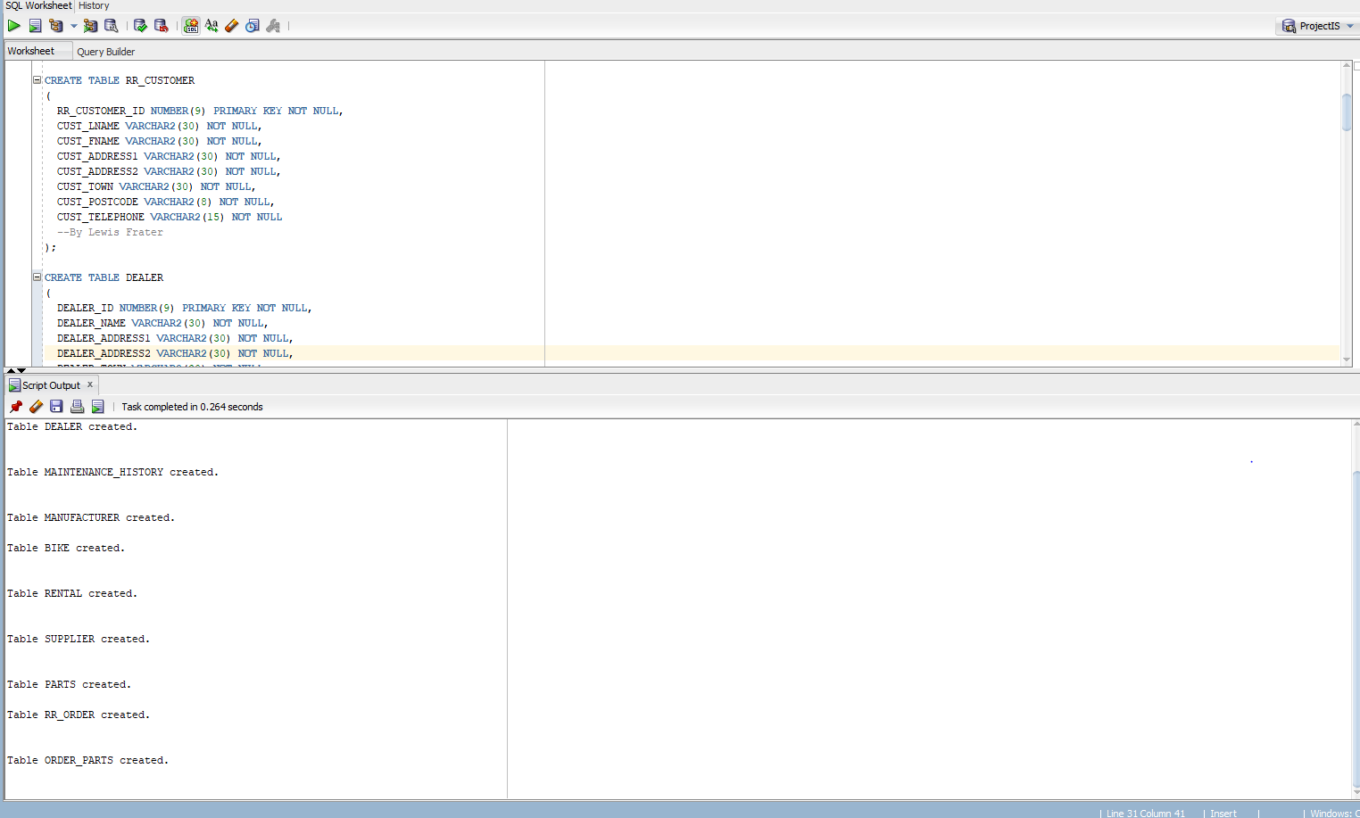

SQL Querys

--Lewis Frater

--Describes the table RR_CUSTOMER, for column names, types of data and constraints etc

DESCRIBE RR_CUSTOMER;

--LEWIS FRATER

SELECT CUST_FNAME, CUST_LNAME , CUST_ADDRESS1 , CUST_ADDRESS2, CUST_TOWN,CUST_POSTCODE

FROM RR_CUSTOMER;

--LEWIS FRATER

--Order by ascending order

SELECT * FROM BIKE

ORDER BY BIKE_NUMBER ASC;

--LEWIS FRATER

--COMPARISON OF PARTS PRICE

SELECT PARTS_PRICE FROM PARTS

WHERE PARTS_PRICE >= 50;

--REBECCA

SELECT PARTS_ID, PARTS_QTY

FROM PARTS

WHERE PARTS_QTY > 0;

--REBECCA

-- ALL PARTS IN STOCK

SELECT PARTS_ID "Parts ID", PARTS_QTY "Stock"

FROM PARTS

WHERE PARTS_QTY > 0;

--REBECCA

--All of a bike’s maintenance history

Select *

FROM MAINTENANCE_HISTORY

ORDER BY MAINTENANCE_HISTORY_ID ASC;

--REBECCA

-- PART PRICE LESS THAN 150

SELECT PARTS_ID, PARTS_NAME "PartN", PARTS_PRICE "Price"

FROM PARTS

WHERE PARTS_PRICE < 150

ORDER BY PARTS_ID ASC;

--Group Function

--Andreas Christofi

SELECT Order_ID

FROM RR_ORDER

WHERE Order_ID > 5

GROUP BY ORDER_ID;

Select RR_CUSTOMER_ID, CUST_FNAME ,CUST_LNAME, CUST_TELEPHONE FROM RR_CUSTOMER;

--Alexander Harrison

Select * FROM BIKE;

--Alexander Harrison

SELECT* FROM MANUFACTURER;

-- CALLUM FLANAGAN

SELECT * FROM DEALER;

--callum flanagan

SELECT* FROM RENTAL;

--Alexander Harrison

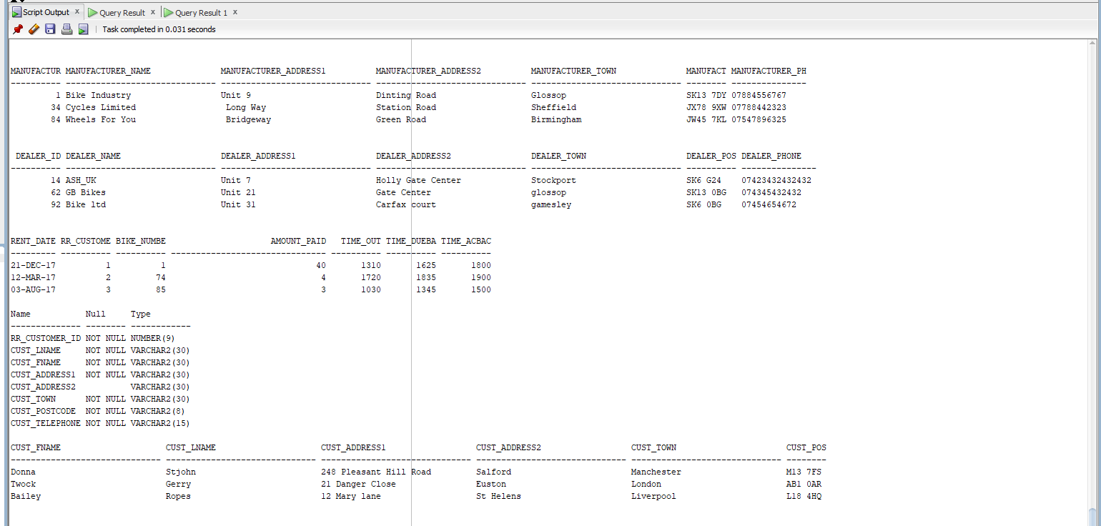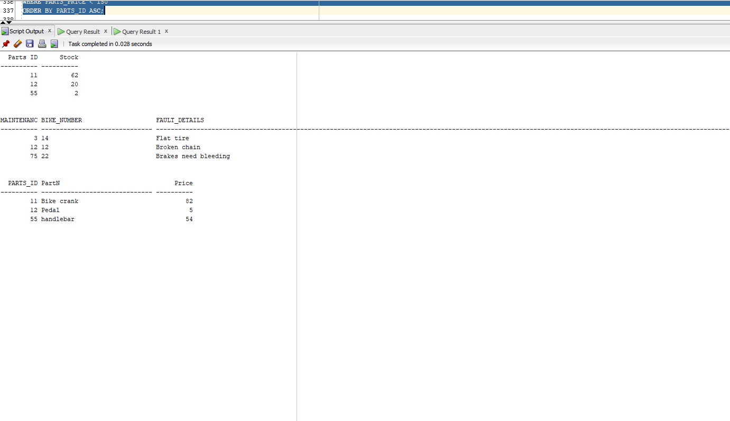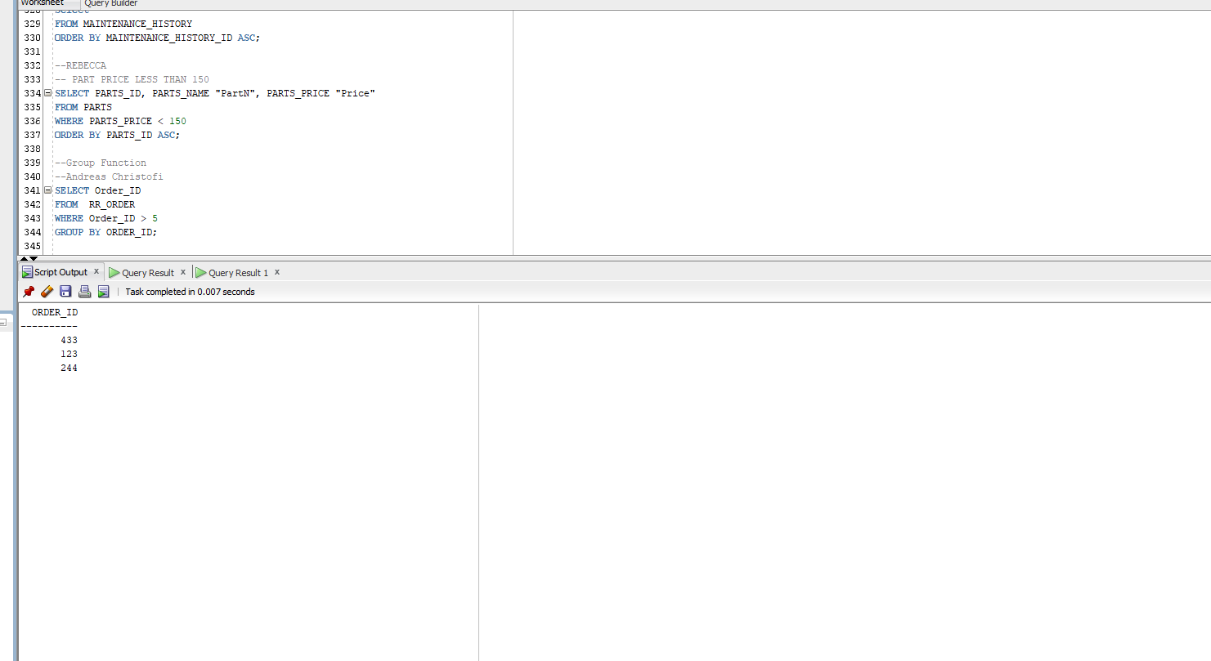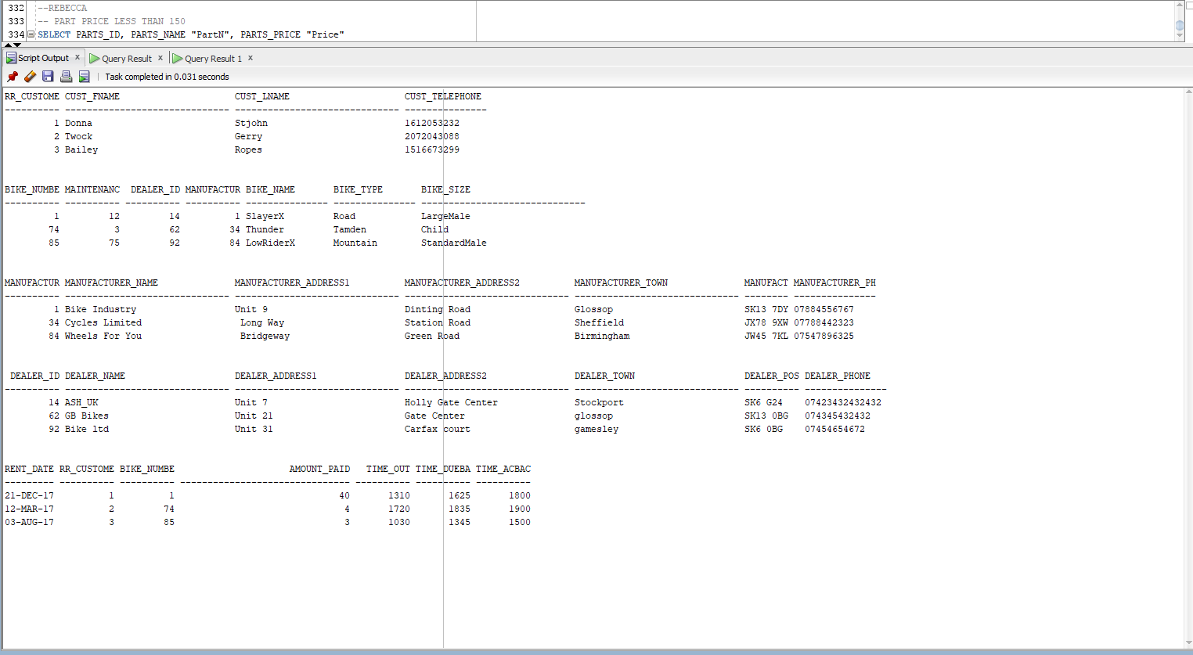

Commentary

***Lewis Frater - Learning on the go***

Part 3 was interesting because we finally got to implement our ERDs within SQL. Writing the SQL code was quite tricky at first as it was a new language to learn. Putting foreign keys into the tables was a trial and error process as it turned out the order tables are created mattered significantly. This was the initial stumbling block we came across as a group.

***Alexander Harrison***

The data dictionaries were easy to do as I have done them before at college and they are very simple to do. When we were working on the SQL for the database we struggled getting the foreign keys working until we realised that the tables had to be created in a specific order and then the sql code became cleared and made it easy to understand.The queries were easy to do wants you understand how they are worded and they make sense after that. Putting the data into the table was a pain as well getting the order correct and getting it set out. We kept running into issues when we created our database that we had to change the ERD for it to work and make sense. We also had a issue that we did not realise you have to drop all of the tables first and then you can actually create the tables.

***Callum Flanagan***

First of all we could not implement out ERD so we had to fix that first which was easy as we only had to make minor changes. Once we had fixed out ERD then we could move on to completing out data dictionaries. The data dictionaries were straight forward as i have visited them before. Moving on to the SQL for the data bad was hard as we had trouble putting the foreign keys into the tables. We also found that the certain tables had to be made first in order to make a different table.

**Rebecca Clarke**

I found this part of the task, not too bad, we had to fix our ERD after doing the implementation as we found that certain tables had to be changed after we did the SQL code, we also had to figure out a lot of things within SQL such as the correct way to input foreign keys as well as the correct format for time, which we thought was the TIME but turned out to be TIMEDATE. Overall i have learnt about different formats for the type of data, how to implement and fix SQL code, how to communicate effectively within the team to fix the SQL code and ERD, as this is sometimes difficult when trying to clarify what different tables mean and also what is meant by certain elements, for example what is the difference between the manufacturer table and the supplier table.

**Andreas Christofi**

Part 3 was a bit difficult on writing the sql code. We had a lot of errors everytime and we had to check every detail every time till we find how to fix everything. We also had a problem on our table’s names because of the already assigned words sql had, like ‘order’ and others. After we went through everything though, I learned how to get over every obstacle and to work and communicate with my team so to make everything work.

**Piazza**

**[Callum Flanagan](https://piazza.com/class/j7j6p4uwzp76zb?cid=39#)**

[10 days ago](https://piazza.com/class/j7j6p4uwzp76zb?cid=39#)

Date 13/2/2018 Time 12-3

We finished data dictionary's and our ERD. Now we are implementing our database design is Oracle.

Attendance

Lewis, Alexander, Callum and Rebecca

Absent

Andreas

**[Callum Flanagan](https://piazza.com/class/j7j6p4uwzp76zb?cid=39#)**

[4 days ago](https://piazza.com/class/j7j6p4uwzp76zb?cid=39#)

Date 19/2/2018 Time 1-3

We are implementing our database design is Oracle.

Attendance

Lewis, Alexander, Callum and Rebecca, and Andreas

**[Alexander Harrison](https://piazza.com/class/j7j6p4uwzp76zb?cid=39#)**

[2 hours ago](https://piazza.com/class/j7j6p4uwzp76zb?cid=39#)

Date 20/2/2018 Time 1-3

We are implementing our database design is Oracle and trying to get our foreign keys to work

Attendance

Lewis, Alexander, Callum and Rebecca, and Andreas

**[Alexander Harrison](https://piazza.com/class/j7j6p4uwzp76zb?cid=39#)**

[2 hours ago](https://piazza.com/class/j7j6p4uwzp76zb?cid=39#)

Date 21/2/2018 Time 1-3

We finished off our database and started working on queries

Attendance

Lewis, Alexander, Callum and Rebecca, and Andreas

**[Alexander Harrison](https://piazza.com/class/j7j6p4uwzp76zb?cid=39#)**

[Just now](https://piazza.com/class/j7j6p4uwzp76zb?cid=39#)

Date 23/2/2018 Time 12-3

We completed the final bits like inserting information into the table and then finished up the report

Attendance

Lewis, Alexander, Callum and Rebecca, and Andreas